Data Analysis
We analysis the data to understand the data and how we can see the pattern and trend about the data. To process the data we examine the data, cleaning, transforming and extract the data in order to get the meaningful or useful information.
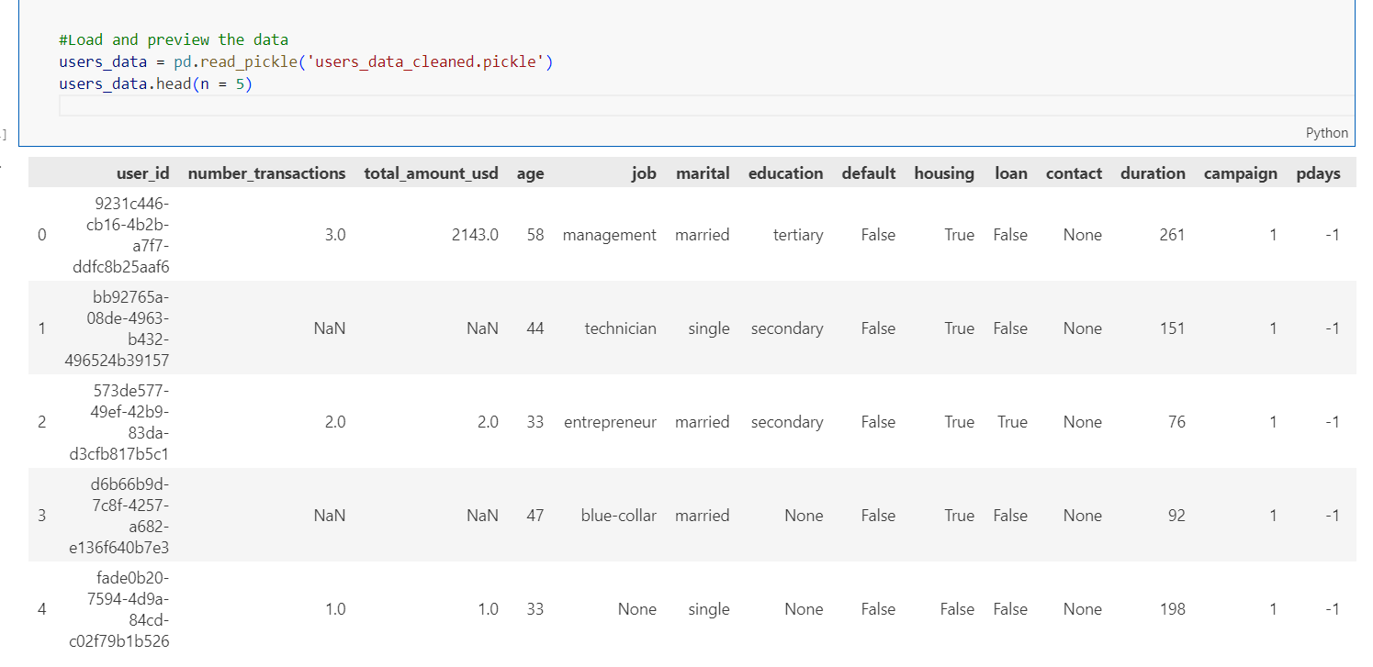

- Load data from pickle file ‘user_data_cleaned’
- Display data with 5 row only

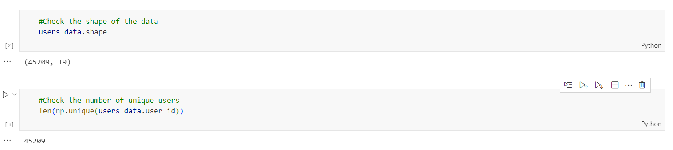
- Check the total row and column of the data
- Row= 45209 and column 19
- Check unique data for user id with the result = 45209

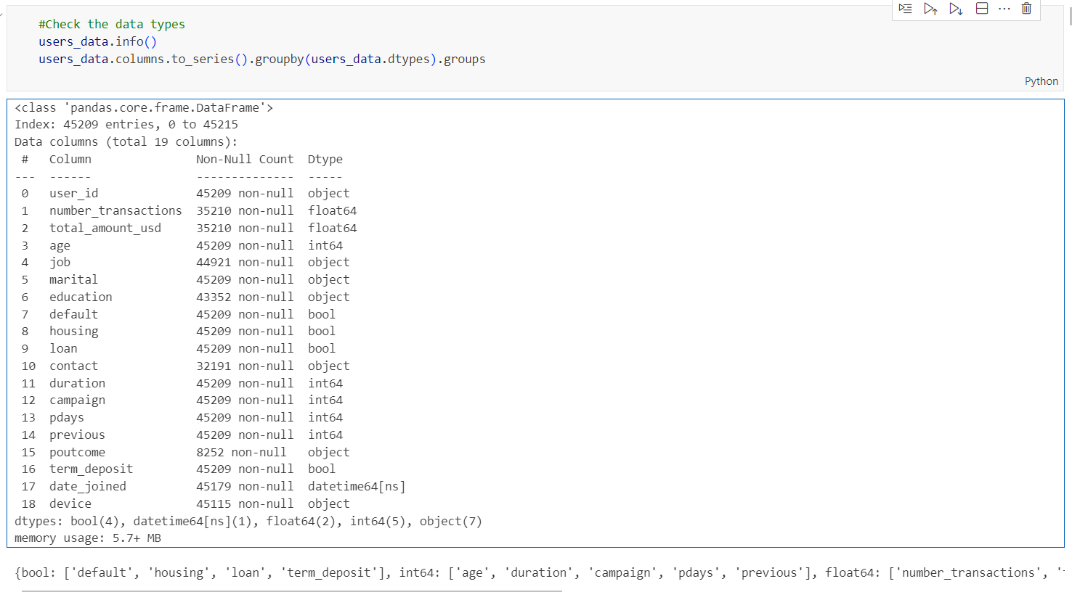
- Check the data info column name and data type for each column
- Total data type of data

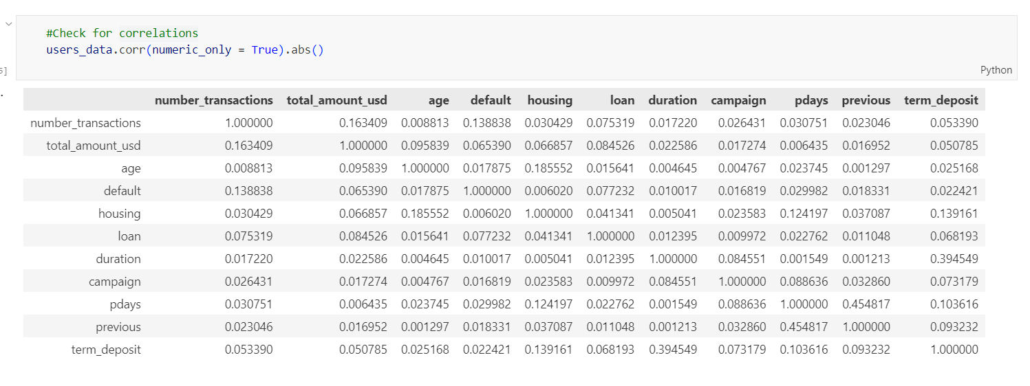
- Check correlation between data
- Check for numeric only
- +1 = positive relationship, -1 = negative relationship , 0 = no relationship
- Example positive relationship : pdays and previous : 0.45817. it is the highest and nearest to 1 . means if the increasing the variable then the others variable would be increasing also.
- Example no relationship or weak relationship : number_transactions and age : 0.008813. it is the lowest and nearest to 0 . means if 0 no relationship between 2 variable or no effect if there have changes between 2 variables.
- Example for simple relationship : housing and age : 0.1855552, it is moderate relationship. The older age can be have their own house.

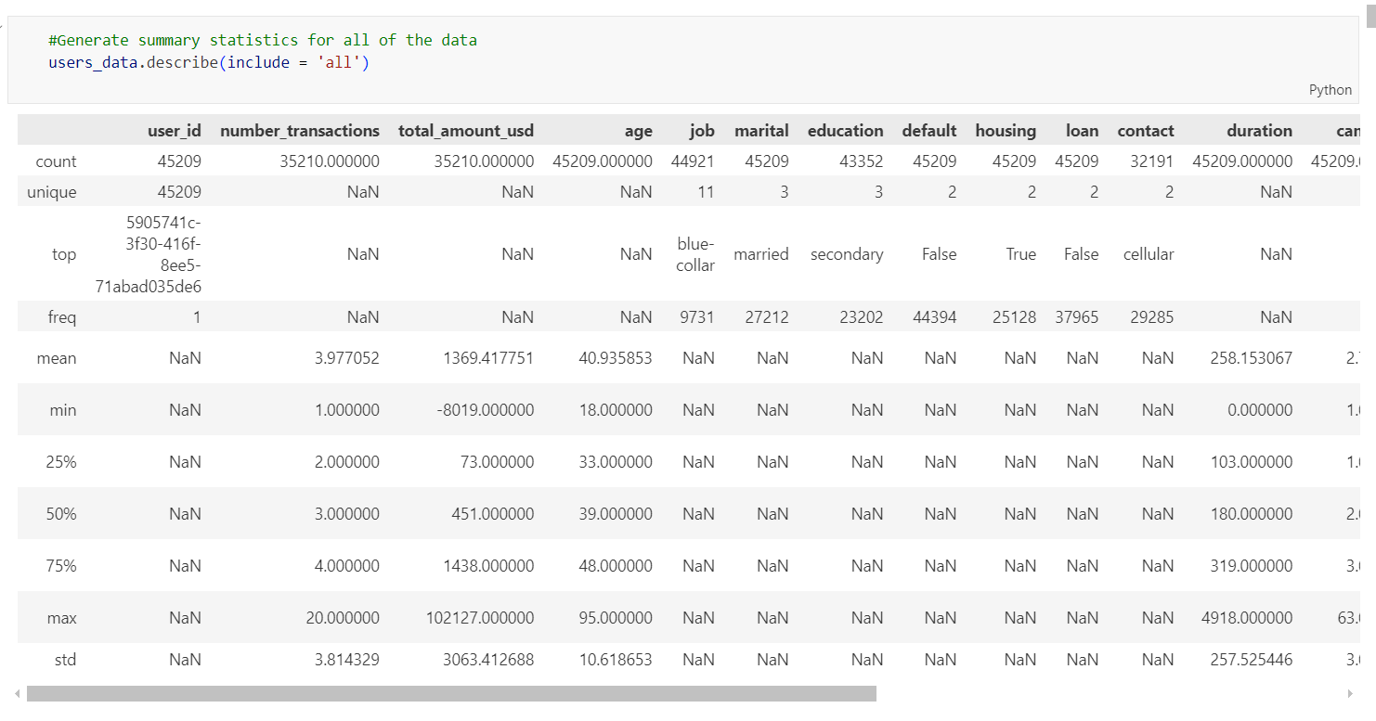
- Check info data about count,unique,top,frequent,mean,min,25%,50%,75%, max and standard for all features
- The purpose to gain the overview of dataset and understand the data before we go to further analysis
- We can also identify the missing value, outliers and error.
- To understand how the data spread and its central tendencies
- Help to transform data and feature selection
- Detect anomalies in min, max and unexpected top values
- Count for column user_id have 45209 and for unique also 45209. From the data there no duplicate data.
- Top value is the most frequent occurring in colum like job which is ‘blue-collar’ and the freq is the total data of the most common in job is about 9731
- Mean is the average value which is central tendency. For example the number_transactions mean is 3.977052 and the standard deviation is 3.814329 which is the measurement of spread data.
- Min for number_transactions is 1 and Max is 20
- 25% for number_transactions is 2 which is (First Quartile, Q1) – The value below which 25% of the data falls
- 50% for number_transactions is 3 which is (Median, Q2) – The middle value of the dataset.
- 75% for number_transactions is 4 which is (Third Quartile, Q3) – The value below which 75% of the data falls.
- The dataset contains both numerical (age, number_transactions, total_amount_usd, duration) and categorical (job, marital, education, default, housing, loan, contact) features.
- Some columns have missing values (NaN), such as job, education, and contact. This because these feature is not a numerical.
- There is a large variation in financial transactions, suggesting different user spending patterns. For example, total_amount_usd the mean transaction is 1369.42 USD and standard deviation is is 3063.41 USD. Which it means that the many transactions are far from average transaction and some users may have spent very little, while others have spent large amounts.
- Potential data issues: Negative values in total_amount_usd may need further investigation. For example min is -8019.00 USD (possibly due to refunds or errors)
- This statistical summary is useful for exploratory data analysis (EDA) before applying further transformations or machine learning models.

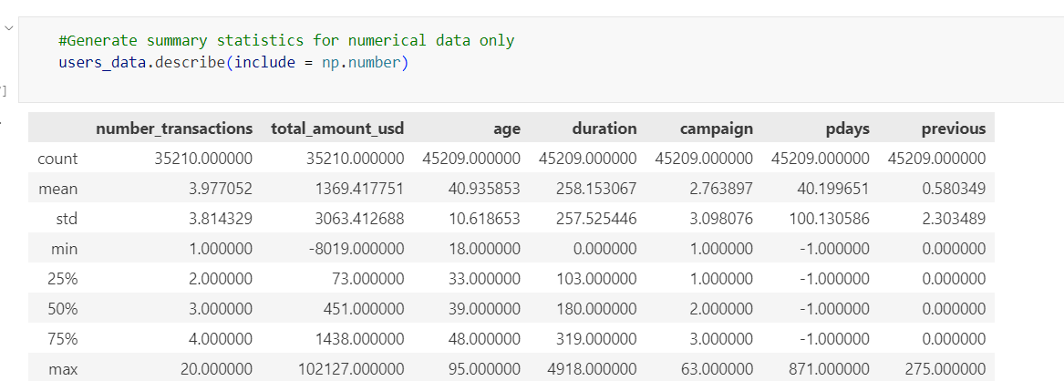
- Check info data about count,unique,top,frequent,mean,25%,50%,75%,max and standard for numeric features only

